Comparative analysis of ML model for AQI prediction in India

Abstract
Air pollution is a severe problem in areas where population density is high such as metropolitan cities. Various types of emissions caused by people's actions, such as transportation, power, and fuel use, are affecting air quality. The machine learning in its components has become the key focus areas of all companies from the early stage of start-ups to major platform vendors. Machine learning is a field in which an artificial intelligence device collects sensor data and learns to act. Air Quality Index is a device used for determining the air quality and the causes of air pollution. The highest possible values that are considered fit for public medical services are relatively higher than the daily air quality quantified attributes. This paper portrays different strategies followed in forecasting the Air Quality Index using supervised machine learning procedures. The supervised machine learning technique (SMLT) was used to analyze a dataset and capture multiple pieces of information, including variable recognition, univariate analysis, bivariate and multivariate analysis, missing value treatments, and data analysis. Moreover, the Estimation of the air quality index can be accomplished based on pollutants causing effect such as CO, Non Metanic Hydrocarbons, Benzene, Total Nitrogen Oxides (NOx) and Nitrogen Dioxide (NO2) These are the components used in supervised machine learning procedures to compare the air quality of an environment. The main goal is to create a machine learning model and investigate the air quality index by predicting the best results from various machine learning algorithms based on their precision.

- Introduction
Air pollution stands as a pressing global concern with far-reaching implications for both human health and environmental well-being. Prolonged exposure to suboptimal air quality, stemming from diverse sources such as vehicular emissions, industrial effluents, mold spores, and wildfires, manifests in a spectrum of adverse health effects. These include irritation of the eyes, nose, and throat, as well as respiratory challenges, cardiovascular complications, and, over extended durations, more serious health ramifications. Beyond the human toll, the environmental repercussions of compromised air quality are equally severe. Impaired air quality has been linked to diminished crop yields, heightened vulnerability of plants to pests and diseases, and broader ecological imbalances. Vigilant monitoring of air quality levels assumes paramount importance for safeguarding both human health and the environment. To this end, this project embarks on an exploration of the Air Quality Dataset. The objective is to develop a robust machine learning (ML) model capable of predicting temperature based on concentrations of various pollutants, including metal oxides and hydrocarbons. This undertaking not only addresses the imperative of air quality management but also provides an opportunity to delve into the intricacies of working with time-series data. In this paper, we used Linear Regression, Random Forest, Gradient Boosting, Ada Boost, Support Vector Regression (SVR), MLP and K nearest neighbors as supervised machine learning algorithms.
- Review of Literature
The field of air pollution prediction has experienced a notable rise in machine learning techniques to address the challenges associated with air quality levels. These techniques have demonstrated their effectiveness in predicting air pollution, thus contributing significantly to developing air quality management strategies. This section comprehensively explores the most notable models utilized for calculating and predicting the Air Quality Index (AQI) and the concentration levels of various air pollutants through different machine learning algorithms, such as regression techniques. These models hold considerable relevance and find practical utility in other application domains such as cloud computing. It was extensively reviewed different methodologies and techniques to analyze the concentration level of air pollution and the prediction of Air quality. This study highlighted the performance of these analytical methods and presented the importance of calculating Air quality as a significant measure for assessing pollution levels and how it dramatically influences human health and the environment. It reviewed air quality models while discussing the effect of air pollution concentration on human health. A noteworthy study were scrutinized the efficiency of four regression methods, namely Support Vector Regression (SVR), Gradient Boosting, Multilayer Perceptron, and Linear Regression in predicting air quality levels. These methods were evaluated based on tracking CO, Non Metanic Hydrocarbons, Benzene, Total Nitrogen Oxides (NOx) and Nitrogen Dioxide (NO2) levels in the air and calculating the AQI. The findings of this study concluded the Random Forest regression method outperformed the others. Moreover, the usage ofutilized the long short-term memory (LSTM) to proposed a deep learning approach for air pollution detection. This study conducted a series of experiments using Detrended Cross-Correlation Analysis (DCCA) to explore the relationship between predicting levels of several air pollutants and meteorological data such as temperature and humidity, The results of this study was observed there were a negative correlation between AQI and meteorological data (temperature, humidity, and wind speed), while a strong positive correlation between pressure and AQI. . The study employed ANN and Random Forest as ensemble learning methods, claiming increased accuracy. However, the feedforward neural network faced challenges predicting continuous values due to insufficient data. For using

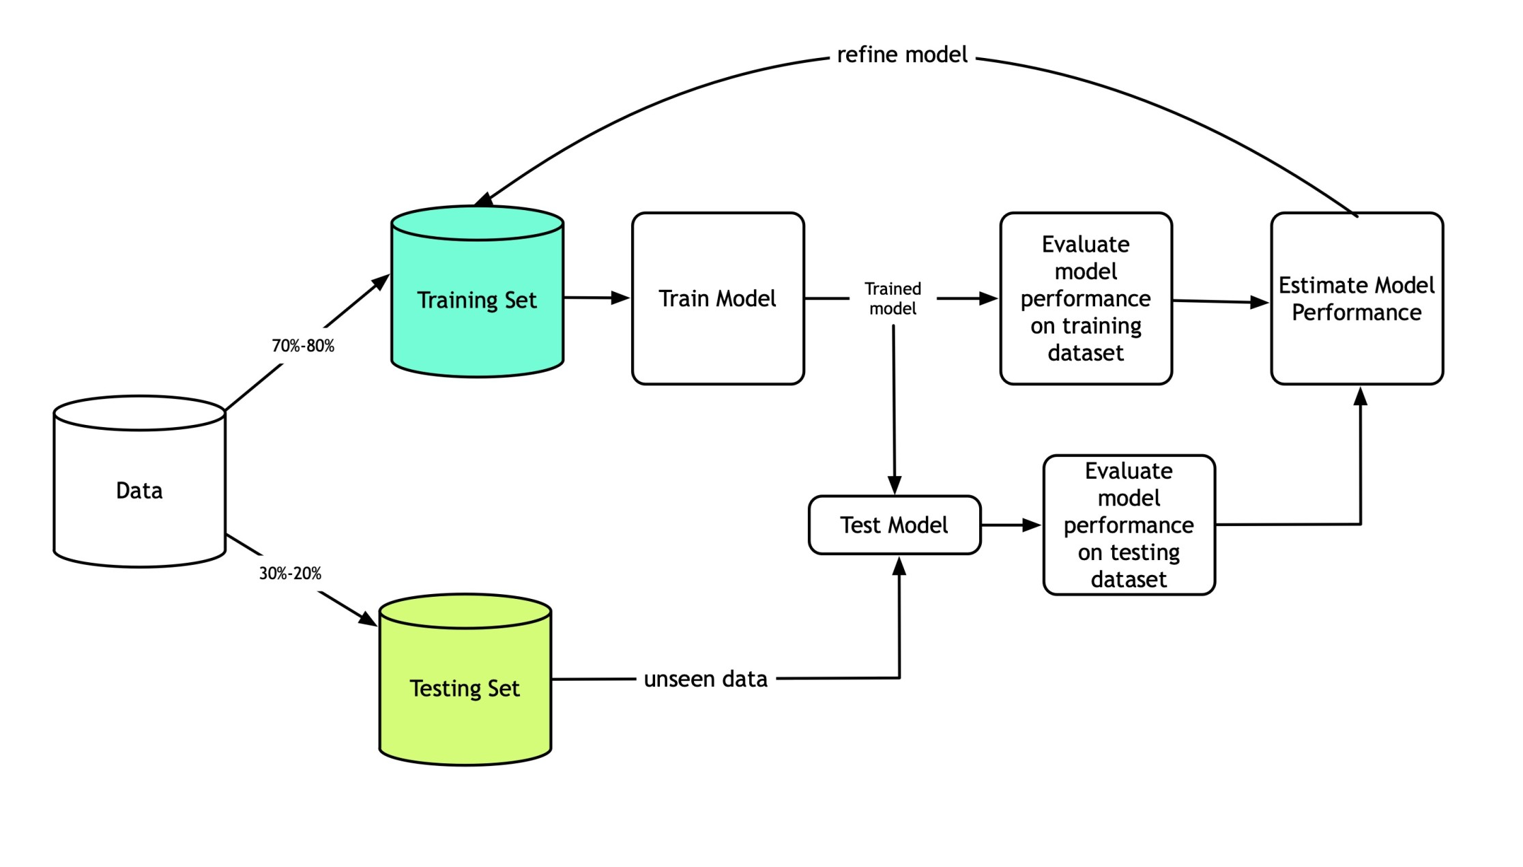
Regression machine learning algorithms, we proposed a classification approach to study how air pollutant levels affect the health of humans. In this process, we employed Linear Regression and Random Forest algorithms and achieved a high accuracy Random Forest using the model. Moreover, we presented a comparative study to compare the performance of several machine learning algorithms, such as Random Forest and K-Neighbor, in analyzing air pollutants and predicting air pollution levels. The study focused on tracking the values of several pollutants, including CO, Non Metanic Hydrocarbons, Benzene, Total Nitrogen Oxides (NOx) and Nitrogen Dioxide (NO2). The research findings indicated that the Gradient Boosting algorithm outperformed the other algorithms, demonstrating its high performance in predicting the AQI and air pollution levels. The presented efficient and cost-effective classification model for environmental monitoring and air pollution prediction. This research highlights the importance of integrating cloud platform solutions to enhance the efficiency and accuracy of monitoring and air quality prediction models, which is beneficial for addressing environment mentoring challenges. The literature review underscores the widespread prediction of air quality and air pollution utilizing machine learning algorithms, highlighting their potential to achieve accurate results, efficient computation, and effective prediction of air quality levels. However, certain limitations need to be addressed. These include the necessity for more extensive and more comprehensive datasets, challenges in accurately predicting continuous values, and the high computational cost associated with model updates. Additionally, the review identifies a research gap in the focus on predicting the AQI based solely on PT08.S1, S2, S3, S4, S5 measurements, neglecting the inclusion of other important air pollutants. Incorporating data on multiple pollutants such as CO, NMHC, NOx, NO2 and O3 significantly enhance the accuracy of air pollution prediction models. These insights provide valuable guidance for future research endeavors and for developing effective air quality management strategies, particularly in smart cities.

- Air Quality Prediction Approach
This section presents our air quality prediction approach and the stages of how to predict air pollution using regression techniques.
Our approach contains six main components: Dataset preprocessing, AQI calculation, Feature selection from
data, Splitting and Balancing data, and Regression model construction for air quality prediction. Air quality datasets were collected and loaded in the first stage for analysis. Next, preprocessing steps were applied to ensure data quality, including handling missing values and reducing outliers. Then, calculate the Air Quality Index (AQI) for air pollutants in the dataset. After processing data, our feature extraction module extracts the most relevant and essential features. This step helps reduce the dimensionality of the air dataset and focuses only on the significant variables. The dataset was then balanced to ensure equal representation of different classes, followed by splitting it into training and testing sets. Finally, our regression module takes the sets of essential features as input and constructs regression classifiers to predict air quality. Performance metrics were computed to identify a suitable and efficient model for predicting air quality. We describe the details of each module next.
Dataset Description:
The dataset contains 9358 instances of hourly averaged responses from an array of 5 metal oxide chemical sensors embedded in an Air Quality Chemical Multisensor Device. The device was located on the field in a significantly polluted area, at road level, within an Italian city. Data were recorded from March 2004 to February 2005 (one year) representing the longest freely available recordings of on field deployed air quality chemical sensor devices responses. Ground Truth hourly averaged concentrations for CO, Non Metanic Hydrocarbons, Benzene, Total Nitrogen Oxides (NOx) and Nitrogen Dioxide (NO2) and were provided by a co-located reference certified analyzer. Evidences of cross-sensitivities as well as both concept and sensor drifts are present as described in De Vito et al., Sens. And Act. B, Vol. 129,2,2008 (citation required) eventually affecting sensors concentration estimation capabilities. Missing values are tagged with -200 value. This dataset can be used exclusively for research purposes. Commercial purposes are fully excluded.th key Attribute Information for the dataset are Date (DD/MM/YYYY), Time (HH.MM.SS), True hourly averaged concentration CO in mg/m^3 (reference analyzer), PT08.S1 (tin oxide) hourly averaged sensor response (nominally CO targeted), True hourly averaged overall Non Metanic HydroCarbons concentration in microg/m^3 (reference analyzer), True hourly averaged Benzene concentration in microg/m^3 (reference analyzer), PT08.S2 (titania) hourly averaged sensor response (nominally NMHC targeted), True hourly averaged NOx concentration in ppb (reference analyzer), PT08.S3 (tungsten oxide) hourly averaged sensor response (nominally NOx targeted), True hourly averaged NO2 concentration in microg/m^3 (reference analyzer), PT08.S4 (tungsten oxide) hourly averaged sensor response (nominally NO2 targeted), PT08.S5 (indium oxide) hourly averaged sensor response (nominally O3 targeted), Temperature in Â°C, Relative Humidity (%), AH Absolute Humidity
Data Pre-processing:
Data pre-processing is an important step in data analysis to improve the quality and reliability of the dataset by reducing noise and inconsistencies.
The first stage of data pre-possessing is handling missing values in the raw data. The dataset used in this study comprised with 9358 instances of hourly averaged responses containing several data types, such as objects, integers, and floats. Some of these entries had null or missing values, which must be addressed. To handle this issue, missing values were replaced with the mean values for pollutant parameters. This approach helped maintain the dataset by ensuring no crucial information was lost due to missing values. Moreover, the interquartile range (IQR) method addresses duplicate observations and outliers. The Interquartile range method utilizes three percentiles: quartiles Q1 (25th), Q2 (50th), and Q3 (75th), and considers the outlier as any values not in the range between (Q1 − 1.5 ∗ IQR) and (Q3 + 1.5 ∗ IQR). Instead of removing the outlier values, we used the lower and upper boundary values to replace them and retain important information while reducing the impact of data outliers on the data analysis process. Exploratory Data Analysis (EDA) has been used to gain insights into the dataset and understand its characteristics for cleaning and preparing the raw data for training purposes. EDA process conducted descriptive statistics of the dataset based on analyzing various statistical measures such as standard deviation, mean, minimum, and maximum values for each air pollutant. By calculating these statistics values, we obtained a comprehensive dataset overview, enabling us to identify potential anomalies that could affect the analysis.
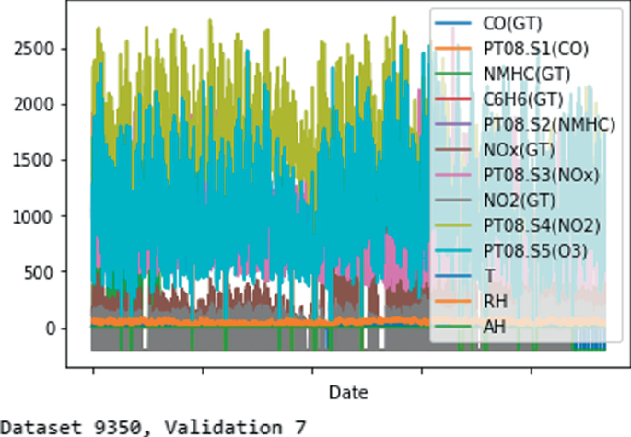
AQI Calculation:
As mentioned before AQI is one of the most crucial parameters have been used for monitoring the air quality in particular cities. It provides a standard measure that quantifies air pollution and helps understand its effects on human health and environment. AQI is a numerical value within a defined range, typically from 0 to 500. A higher value of AQI indicates poorer air quality and the existence of harmful air pollutants. Each pollutant has specific constraints and specific averaging periods to ensure accurate assessment such as the period is 8-hour maximum for including CO, Non Metanic Hydrocarbons, Benzene, Total Nitrogen Oxides (NOx) and Nitrogen Dioxide (NO2).
To calculate the AQI, the concentrations of these air pollutants are categorized into sub-indices. These sub-indices were defined based on predefined ranges that help to give the level of air quality, ranging from ‘‘good’’ to ‘‘hazardous.’’ Where the highest value of sub-index among the air pollutants represents the overall air quality index for a certain location. The computation of the AQI is based on Equation 1 combines the sub-indices of each pollutant which considers the weightage assigned to each pollutant based on its potential health impacts, by incorporating multiple pollutants and their respective sub-indices, the AQI helps to assess the air quality.
Ihigh ⁻ Ilow
I = (C − I_{low}) + I_{low} (1)
Chigh ⁻ Clow where, I is Air Quality Index, C is Pollutant concentration.
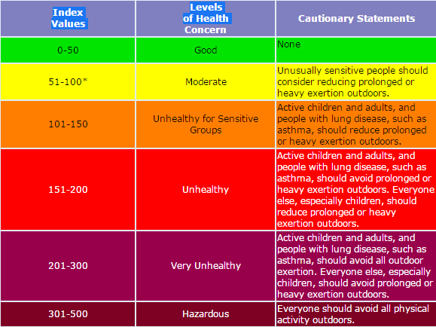

Feature Selection:
Feature selection becomes crucial in our research following the data preprocessing and exploratory data analysis step. This process involves identifying and selecting the most relevant features related to the AQI, representing the overall air quality. The features in this study based on the preprocessed dataset contain several pollutant information such as CO, NMHC, NOx, NO2 and O3 along with their corresponding AQI values.
We used the correlation analysis to determine the relationship between the features and AQI. Correlation analysis can be used to find the linear relationship between two variables. By calculating the correlation coefficients between each feature and the AQI, we can assess their predictive value in understanding and predicting variations in air pollutant levels. The correlation values are compiled into a correlation matrix, which provides a view of the relationships between all dataset variables and identifies features. The results of this study highlighted that most values of air pollutants demonstrated a positive correlation with the AQI values, which indicates that higher concentrations of air pollutants are associated with higher AQI values, reflecting poorer air quality. This highlights how selecting important air pollutants as features that represent significant correlations with the AQI is essential in analyzing and predicting air quality variations in the study area.
Splitting Data:
In this stage, the train-test split () method was utilized to split the data into two parts with a ratio of 80:20 for training and testing sets. This means 80% of the total dataset was chosen for training, while the remaining 20% of data was assigned for testing data. With this splitting ratio, the model is trained on a large sufficient portion of the data and evaluated on test data to assess its performance.

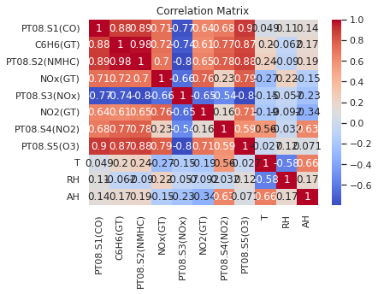
Balancing Data:
In machine learning tasks, addressing the issue of imbalanced data is a crucial process to ensure reliable and accurate prediction results. In this study, the distribution of AQI values exhibits an imbalance in the given dataset, where certain values occur more frequently than others.

This can be observed by categorizing the AQI values into predefined ranges. Using imbalanced data can significantly effects on the regression approaches. By utilizing balancing the dataset, the regression models are trained using more representative and several sets of data points. In this stage, the model’s ability to capture patterns and relationships across different AQI values of air pollutants will be enhanced, leading to improved model performance and more accurate predictions.
Regresssion Models Construction:
The final step in the air quality prediction approach is constructing a regression model to predict air quality. For this task, we train models using the following regression techniques.
- Linear regression: is a commonly employed statistical method in several approaches for prediction and forecasting air pollution. It is used for examining the relations between pollutant concentrations and the AQI. Linear regression can make reliable predictions about future air pollution levels by analyzing historical data and discerning trends and patterns. Furthermore, Linear regression aids in identifying the primary factors contributing to air pollution. By assessing the regression coefficients, it becomes possible to determine how much the variable influences the AQI. This information can be crucial in formulating effective control measures to mitigate pollution and enhance air quality.
- Random Forest regression: is a supervised learning technique that combines multiple Decision Trees and can be used for regression problems. The input data goes through multiple Decision Trees, and the average of each tree is used as the model’s output in the training process.
Evaluation Metrics
In our evaluation stage, we aim to offer a comprehensive analysis of different regression approaches and performance metrics to provide the flexibility to select the classifier whose accuracy specifications are most relevant to users. Therefore, this part implies the most popular error rate metrics used in machine learning and information retrieval domains. We list these measures and explain each one next.

- Mean Absolute Error (MAE): is a metric used to calculate the mean value for the differences between the actual and predicted values observed from the model. It indicates the average of the model errors, as shown in the equation below:

n
1 X ′
MAE = (y_{j} − y_{j}) n

- Root Mean Square Error (RMSE): is a widely used for evaluating regression models. It is used to calculate the average deviation between predicting and actual model values. A lower RMSE value highlighted that the model achieved better performance. It can be calculated using the following formula:

v
u^{u}1( (y_{j} − y_{j}) ) RMSE = _{t}
n
X
′
2
n
j=1
- R² Score: is used to find the variance of target variables in the model. It ranges from 0 to 1, with a higher value representing that the proposed model fits the dataset in a good way. It is calculated using the following formula:
Pn ₍y^{i} − y′)2
R2 = 1 − i=1
Pn (yi − ¯yi)2 i=1

- Mean Squared Error (MSE): In Statistics, the mean squared error is a risk function that measures that square of errors. When performing regression, use MSE if you believe your target is normally distributed and you want large errors to be penalized more than small ones. It is calculated using the following formula:
MSE = Σ (y i − pi) ^2 n

Our initial set of evaluation findings showcases the performance of our approaches in predicting air quality by comparing the actual values with the prediction values generated by models. By visually comparing these two sets of values, we can quickly assess the degree of proximity between them, offering valuable insights into the accuracy of each model. The actual values plotted versus the predicted values, focusing specifically on linear regression results. The blue line represents the ideal regression line, and the model’s accuracy depends on the degree of alignment between the data points and this line. Upon examining the linear regression results, it becomes evident that the data points are clustered at the bottom of the graph and are not closely aligned with the regression line. This observation suggests that linear regression may not be the most suitable model for air quality prediction in this study. From the study the data points are well suited and closely aligned to the regression line while focusing on the Gradient Boosting results in the model’s accuracy.

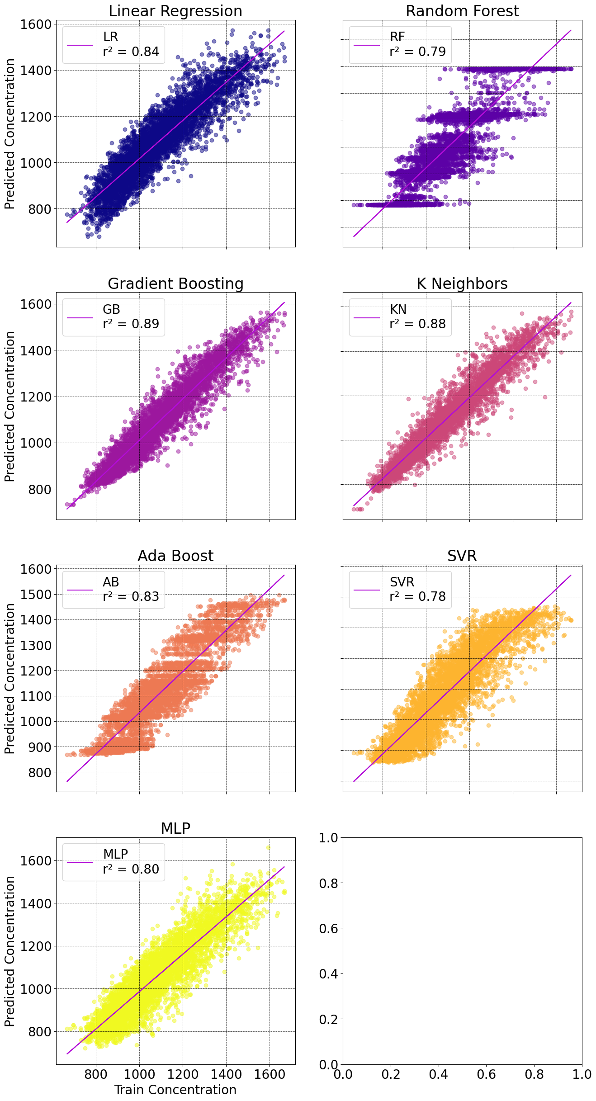
- Experimental Results
To validate reliability and effectiveness of air quality prediction methodologies, we present all experimental findings and compare them from different perspectives. Our initial evaluation focuses on comparing the actual and predicted values of each approach to provide a reliable indicator of approaches accuracy.
Moreover, we emphasized measuring the execution times for each regression technique on both selected platforms. This analysis provides valuable insights into the computational efficiency and speed of the models. In the Gradient Boosting regression model. Analyzing the results, we observe that the data points are more evenly distributed throughout the graph and closer to the regression line than the Linear regression case. This indicates that our study’s Gradient Boosting regression model performs better in predicting air quality. The improved distribution and proximity of data points to the regression line in the case of Gradient Boosting regression signify a higher level of accuracy and reliability in predicting air quality compared to linear regression. This suggests that the Gradient Boosting regression model may provide more precise predictions based on the dataset. Concluding the evaluation of regression models. The comparison values of the Random Forest regression model. Upon analysis, we observe that the data points are distributed and closer to the regression line, and this graph looks similar to the Gradient Boosting model graph. While the Random Forest model may offer advantages in handling complex relationships and reducing overfitting, the Gradient Boosting model’s simplicity and interpretability make it a compelling option for understanding the factors influencing air quality. The Gradient Boosting model can provide valuable insight into the variables representing the most significant impact on air quality, aiding decision-making processes.
Index no | Method | Test R2
2 | Gradient Boosting | 0.885359
3 | K- Neighbors | 0.882122
0 | Linear Regression | 0.835696
4 | Ada Boost | 0.831578
6 | MLP | 0.799912
1 | Random Forest | 0.787914
5 | SVR | 0.780383

- Conclusion

This study provides a comprehensive comparative analysis of different regression models for predicting air quality in smart cities. Notably, Gradient Boosting regression model demonstrated a high performance compared to other regression models. Incorporating Exploratory Data Analysis played a pivotal role in enhancing model accuracy by addressing data imbalances and optimizing feature selection. Moreover, the study emphasized the advantages of utilizing cloud computing in regression modeling. Utilizing cloud resources led to reduced model execution time, resulting in enhanced efficiency and scalability. This accelerated experimentation, training, and deployment of the models, enhancing their practical applicability in real-world applications.
For future work recommendations, we explore diverse machine-learning approaches for predicting air quality and air pollution in smart cities. Additionally, investigating the effect of meteorological data, including temperature, pressure, humidity, and wind speed, further enhances AQI and air pollution prediction accuracy. This endeavor provides valuable insight into identifying air quality levels and contributes to more effective air quality management approaches.

